RGA Users Guide

## Version 1.0

First draft: Author RFC. Date 06/04/2017

# Synoptic screens

The synoptic screens will show the RGAs in green if the interlocks are working. The second value is the total pressure

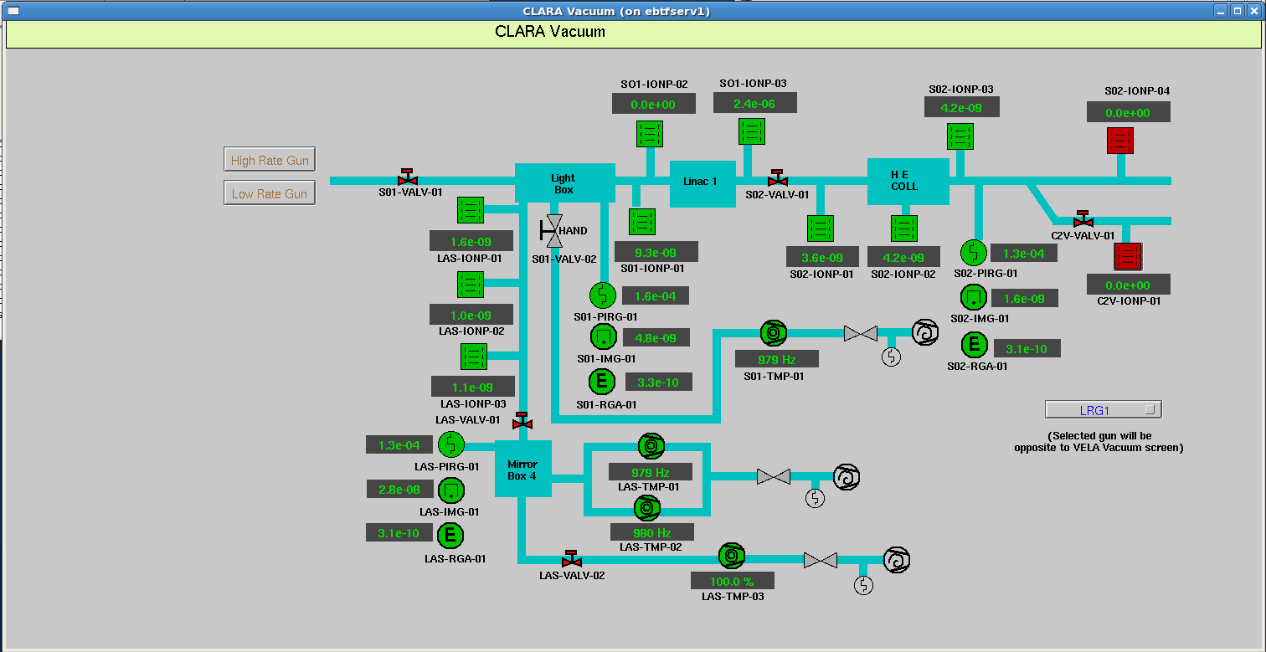

## Synoptic summary

Click on the green icon and a summary display will popup. From here a filament can be selected, the M1/M2/M3 and scan mode selected, etc. An EDM bar chart and a strip tool graph popups are also found from here

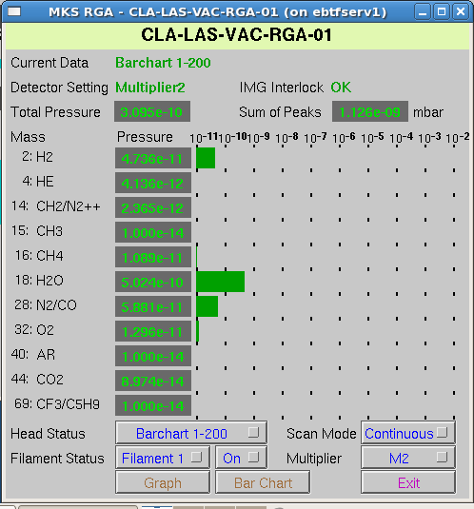

## Synoptic Bar Chart

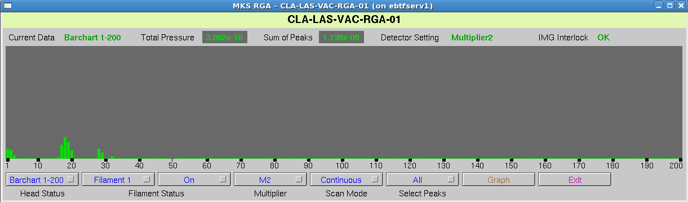

Click on peak for local information

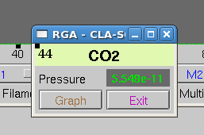

## Synoptic Strip Tool

## 

# The RGA tool

The controls group have developed a QT interface to the RGA that can run under windows or from the Synoptic screens.

To launch form the synoptic screens:

CLARA🡪Commissioning🡪RGAs

## RGA Main screen

1. Device information along with the interlock status
2. Summary strip plot and bar charts
3. Bar charts and analog scan summary for all six RGAs
4. Progress of current scan
5. Scan mode, ANA/BAR 50,100, 200
6. Archive scan mode

The archive scans repeatedly scans BAR-200 for one hour, runs an analog scan, then returns to a repeating a BAR scan.

When the archive mode is started, all previous scans are stopped, the filaments are powered up and the BAR-200 scans start first. Any errors will drop the Mode for that RGA into an “undefined” state. Faraday/M1/M1/M3 are set by the user

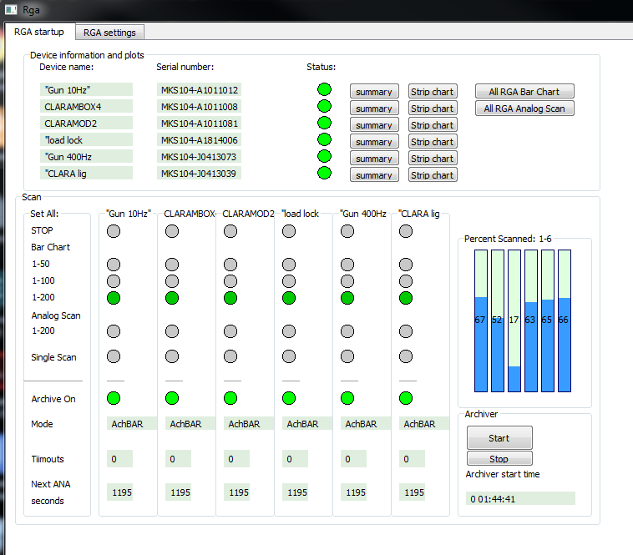

**6**

**5**

**4**

**3**

**2**

**1**

## RGA details screen

Each box lists one RGA unit. The interlock, filament and Multiplier mode can be set here. Information about the scan sensitivity is shown along with voltages

Char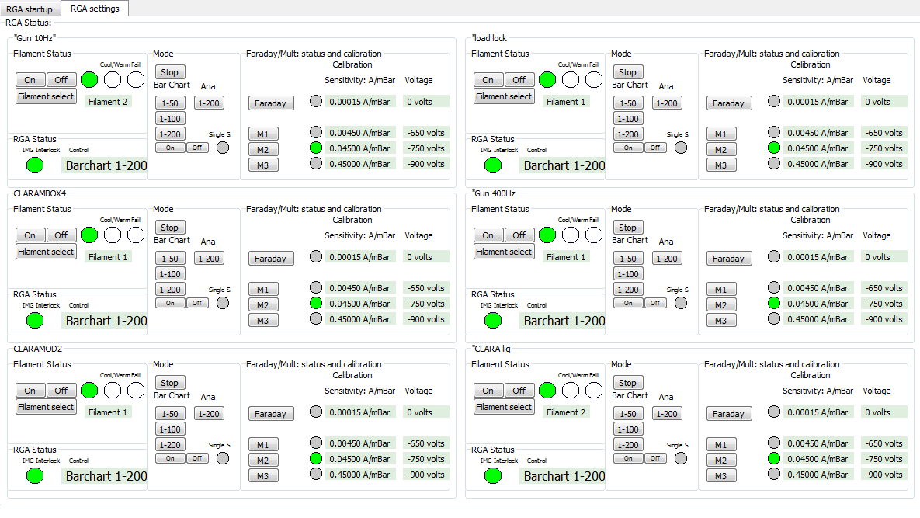

## Ana/Bar charts

These are updated at the end of a scan.

**To find the value of a peak:**

Place the cross hair on the top of the peak, right click, select “Export Mass and Pressure”. The values at the bottom of the screen will give the value

**To hide/show RGAs:**

Use the tick boxes on the the right hand side

**To zoom an axis:**

Either middle mouse and drag the green box. This can be is difficult, the fastest way is to select My, or Mx and put a range

**Normalise/Dynamic:**

The RGAs can be normalised to 1 or real value. “N” button to normalise and Dy for the real value

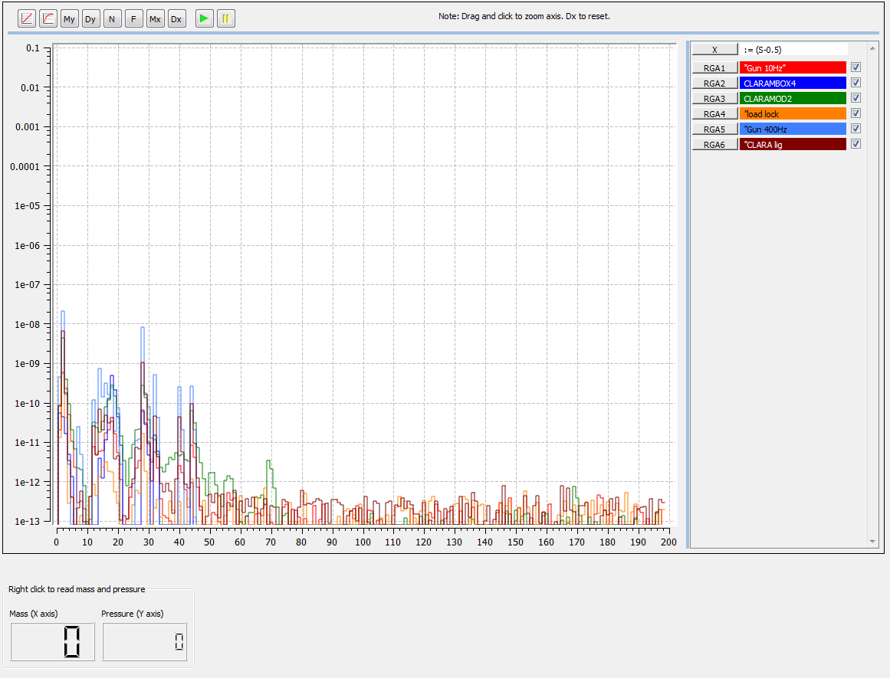

## Strip tool

Each line shows an RGA. Hover over a line and wait for a square box.

**To hide/show:**

Right click on the coloured name bar and select 🡪 Line 🡪 Hide/Show

**Values**

Click to get a reading for the values at that point

**Range**

The buttons at the top can select a range between 1m and two days. Use the calendar, to the right under “real time”, for custom ranges

**Archive**

Use the calendar, to the right under “real time”, for custom ranges and then “extract data from Archive” button(Still setting this up)

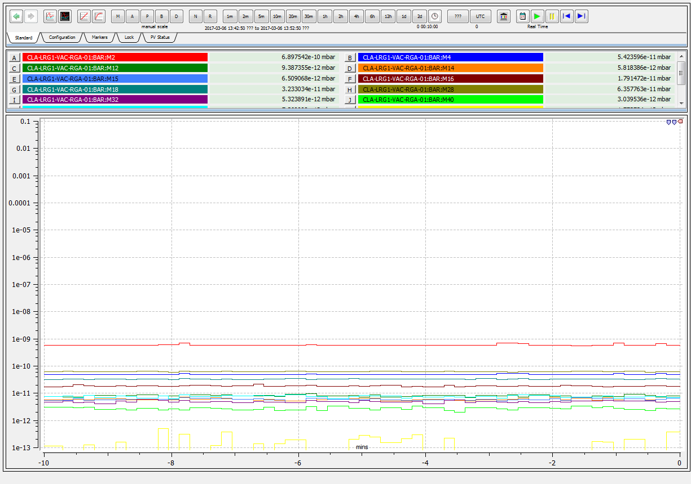

## Summay Plot

